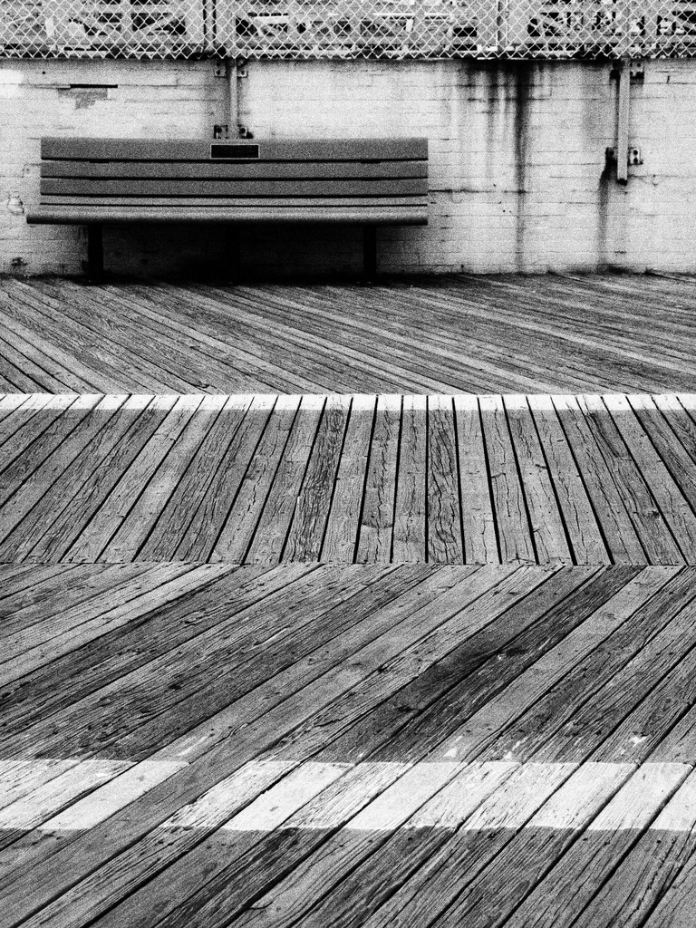

I chose this picture for several purposes, first off the simplicity and repetitions throughout make this a visually appealing photo to look at. In addition to this, it is so generic that it almost makes you feel as if you have been here yourself from one time or another. The texture of the wood is so perfect and almost flawless looking, but as you work up the photo toward the wall there are dirt and water stains which are very visible. These help break up the monotony of the image. Finally, aside from this being a simple picture with nice contrast and a good use of leading lines it almost leaves a question or void within the viewer. I almost expected to see something sitting on the bench, be it an animal, person, a random object, it would have given the image more of a purpose and subject.